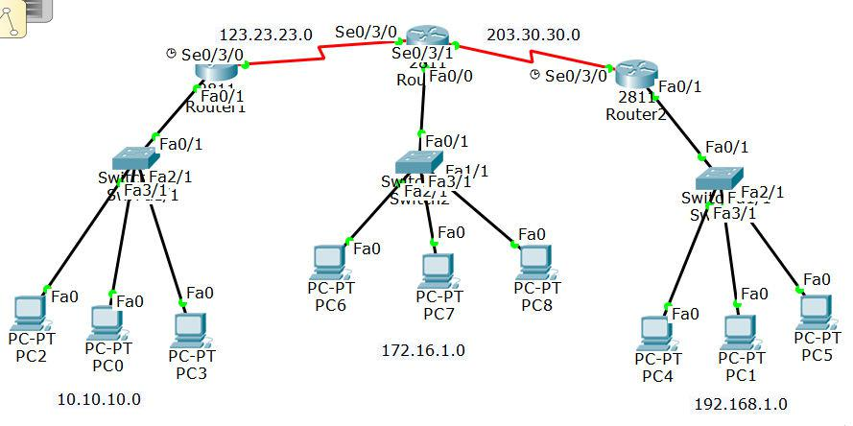

**Default Route, Configuration**

**ROUTER-1:**

Router(config)#interface FastEthernet0/1

Router(config-if)#ip address 10.10.10.1 255.255.255.0

interface Serial0/3/0

Router(config-if)#ip address 123.23.23.1 255.255.255.0

Router(config)#ip route 0.0.0.0 0.0.0.0 123.23.23.2

**ROUTER-0:**

Router(config)#interface FastEthernet0/0

Router(config-if)#ip address 172.16.1.1 255.255.255.0

Router(config)#interface Serial0/3/0

Router(config-if)#ip address 123.23.23.2 255.255.255.0

Router(config)#interface Serial0/3/1

Router(config-if)#ip address 203.30.30.1 255.255.255.0

Router(config)#ip route 0.0.0.0 0.0.0.0 123.23.23.1

Router(config)#ip route 0.0.0.0 0.0.0.0 203.30.30.2

**ROUTER-2:**

Router(config)#interface FastEthernet0/1

Router(config-if)#ip address 192.168.1.1 255.255.255.0

Router(config)#interface Serial0/3/0

Router(config-if)#ip address 203.30.30.2 255.255.255.0

Router(config)#ip route 0.0.0.0 0.0.0.0 203.30.30.1